**SE – Overview of IT Industry**

1. What is software? What is software engineering?

Ans.1 **Software:** Software refers to a set of instructions or programs that are designed to perform specific tasks on a computer or a device. It includes both application software e.g., word processors and system software e.g., operating systems.

**Software Engineering:** Software engineering is a systematic and disciplined approach to the development, operation, and maintenance of software. It involves the application of engineering principles to software development, addressing both technical and managerial aspects to ensure the creation of high-quality software.

1. Explain types of software

Ans.2 There are four types of software: -

**System Software:** Manages and controls hardware and provides a platform for running application software (e.g., Notepad, Calculator).

**Application Software:** Performs specific tasks for users (e.g., Power Point, Microsoft).

**Programming Software:** Helps programmers develop software (e.g., compilers, Turbo C).

**Utilities:** Perform a specific task, usually related to managing system resources (e.g., antivirus software, disk cleanup tools).

1. What is SDLC? Explain each phase of SDLC

Ans.3 SDLC is a process used by software developers to design, develop, test, and deploy software. It consists of the following phases:

1. **Planning:** Define the scope, requirements, and objectives.
2. **Analysis:** Gather and analyze requirements.
3. **Design:** Create a detailed design of the software architecture.
4. **Implementation:** Code the software based on the design.
5. **Testing:** Verify that the software meets specifications.
6. **Deployment:** Release the software for use.
7. **Maintenance:** Fix bugs, make improvements, and provide support.
8. What is DFD? Create a DFD diagram on Flipkart

Ans.4 **Data Flow Diagram (DFD);** DFD is a visual representation of how data flows within a system.

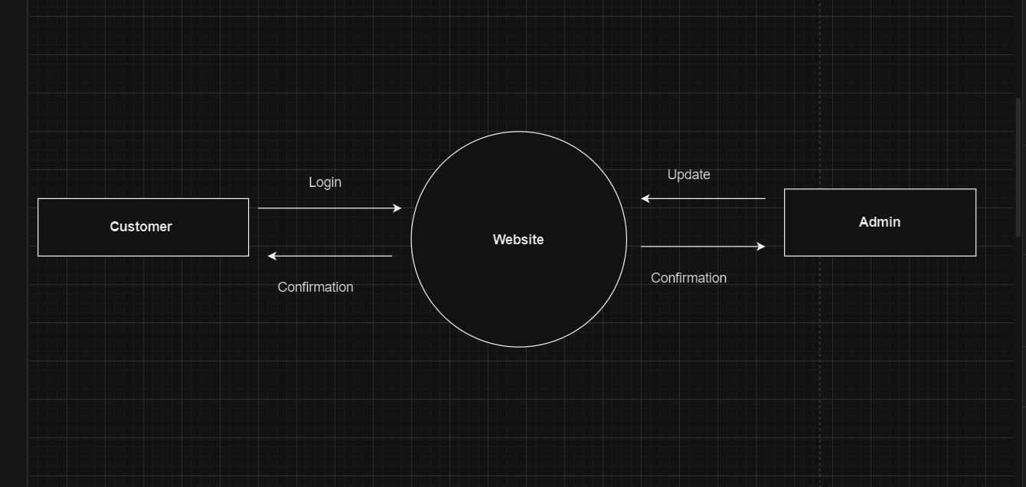

5. What is Flow chart? Create a flowchart to make addition of two numbers

Ans.5 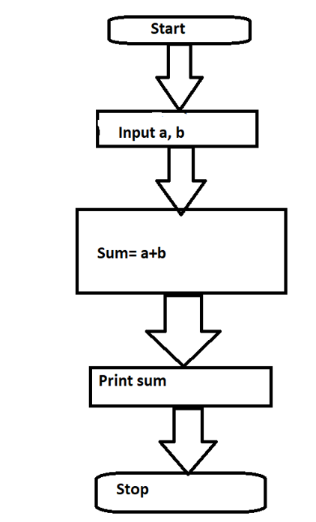

1. What is Use case Diagram? Create a use-case on bill payment on paytm.

Ans.6 A use-case diagram describes a system's high-level functions and scope. These diagrams also represent the system's interactions with its actors. The use cases and actors in use-case diagrams describe what the system does and how the actors interact with it.

